Distance Vector Routing Protocols
Most routing protocols fall into one of two classes: distance vector or link state. The basics of distance vector routing protocols are examined here; the next section covers link state routing protocols. Most distance vector algorithms are based on the work done of R. E. Bellman, L. R. Ford, and D. R. Fulkerson, and for this reason occasionally are referred to as Bellman-Ford or Ford-Fulkerson algorithms. A notable exception is EIGRP, which is based on an algorithm developed by J. J. Garcia Luna Aceves.
R. E. Bellman. Dynamic Programming. Princeton, New Jersey: Princeton University Press; 1957.
L. R. Ford Jr. and D. R. Fulkerson. Flows in Networks. Princeton, New Jersey: Princeton University Press; 1962.
The name distance vector is derived from the fact that routes are advertised as vectors of (distance, direction), where distance is defined in terms of a metric and direction is defined in terms of the next-hop router. For example, "Destination A is a distance of five hops away, in the direction of next-hop Router X." As that statement implies, each router learns routes from its neighboring routers' perspectives and then advertises the routes from its own perspective. Because each router depends on its neighbors for information, which the neighbors in turn might have learned from their neighbors, and so on, distance vector routing is sometimes facetiously referred to as "routing by rumor."
Distance vector routing protocols include the following:
- Routing Information Protocol (RIP) for IP
- Xerox Networking System's XNS RIP
- Novell's IPX RIP
- The Cisco Systems Internet Gateway Routing Protocol (IGRP) and Enhanced Internet Gateway Routing Protocol (EIGRP)
- DEC's DNA Phase IV
- AppleTalk's Routing Table Maintenance Protocol (RTMP)

Common Characteristics
A typical distance vector routing protocol uses a routing algorithm in which routers periodically send routing updates to all neighbors by broadcasting their entire route tables.
A notable exception to this convention is the Cisco Enhanced IGRP. EIGRP is a distance vector protocol, but its updates are not periodic, are not broadcasted, and do not contain the full route table. "Enhanced Interior Gateway Routing Protocol (EIGRP)."
The preceding statement contains a lot of information. Following sections consider it in more detail.

Periodic Updates
Periodic updates means that at the end of a certain time period, updates will be transmitted. This period typically ranges from 10 seconds for AppleTalk's RTMP to 90 seconds for the Cisco IGRP. At issue here is the fact that if updates are sent too frequently, congestion and router CPU overloading might occur; if updates are sent too infrequently, convergence time might be unacceptably high.

Neighbors
In the context of routers, neighbors means routers sharing a common data link or some higher-level logical adjacency. A distance vector routing protocol sends its updates to neighboring routers and depends on them to pass the update information along to their neighbors. For this reason, distance vector routing is said to use hop-by-hop updates.
^{[6]} This statement is not entirely true. Hosts also can listen to routing updates in some implementations; but all that is important for this discussion is how routers work.

Broadcast Updates
When a router first becomes active on a network, how does it find other routers and how does it announce its own presence? Several methods are available. The simplest is to send the updates to the broadcast address (in the case of IP, 255.255.255.255). Neighboring routers speaking the same routing protocol will hear the broadcasts and take appropriate action. Hosts and other devices uninterested in the routing updates will simply drop the packets.

Full Routing Table Updates
Most distance vector routing protocols take the very simple approach of telling their neighbors everything they know by broadcasting their entire route table, with some exceptions that are covered in following sections. Neighbors receiving these updates glean the information they need and discard everything else.

Routing by Rumor
Figure 4-3 shows a distance vector algorithm in action. In this example, the metric is hop count. At time t₀, Routers A through D have just become active. Looking at the route tables across the top row, at t₀ the only information any of the four routers has is its own directly connected networks. The tables identify these networks and indicate that they are directly connected by having no next-hop router and by having a hop count of 0. Each of the four routers will broadcast this information on all links.

Figure 4-3 Distance vector protocols converge hop-by-hop.
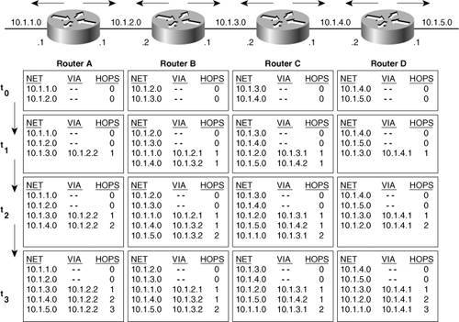

At time t₁, the first updates have been received and processed by the routers. Look at Router A's table at t₁. Router B's update to Router A said that Router B can reach networks 10.1.2.0 and 10.1.3.0, both zero hops away. If the networks are zero hops from B, they must be one hop from A. Router A incremented the hop count by one and then examined its route table. It already recognized 10.1.2.0, and the hop count (zero) was less than the hop count B advertised, (one), so A disregarded that information.
Network 10.1.3.0 was new information, however, so A entered this in the route table. The source address of the update packet was Router B's interface (10.1.2.2) so that information is entered along with the calculated hop count.
Notice that the other routers performed similar operations at the same time t₁. Router C, for instance, disregarded the information about 10.1.3.0 from B and 10.1.4.0 from C but entered information about 10.1.2.0, reachable via B's interface address 10.1.3.1, and 10.1.5.0, reachable via C's interface 10.1.4.2. Both networks were calculated as one hop away.
At time t₂, the update period has again expired and another set of updates has been broadcast. Router B sent its latest table; Router A again incremented B's advertised hop counts by one and compared. The information about 10.1.2.0 is again discarded for the same reason as before. 10.1.3.0 is already known, and the hop count hasn't changed, so that information is also discarded. 10.1.4.0 is new information and is entered into the route table.
The network is converged at time t₃. Every router recognizes every network, the address of the next-hop router for every network, and the distance in hops to every network.
It is time for an analogy. You are wandering in the Sangre de Cristo mountains of northern New Mexicoa wonderful place to wander if you aren't lost. But you are lost. You come upon a fork in the trail and a sign pointing west, reading "Taos, 15 miles." You have no choice but to trust the sign. You have no clue what the terrain is like over that 15 miles; you don't know whether there is a better route or even whether the sign is correct. Someone could have turned it around, in which case you will travel deeper into the forest instead of to safety!
Distance vector algorithms provide road signs to networks. They provide the direction and the distance, but no details about what lies along the route. And like the sign at the fork in the trail, they are vulnerable to accidental or intentional misdirection. Following are some of the difficulties and refinements associated with distance vector algorithms.
^{[7]} The road sign analogy is commonly used. You can find a good presentation in Radia Perlman's Interconnections, pp. 205210.

Route Invalidation Timers
Now that the network in Figure 4-3 is fully converged, how will it handle re-convergence when some part of the topology changes? If network 10.1.5.0 goes down, the answer is simple enough Router D, in its next scheduled update, flags the network as unreachable and passes the information along.
But what if, instead of 10.1.5.0 going down, Router D fails? Routers A, B, and C still have entries in their route tables about 10.1.5.0; the information is no longer valid, but there's no router to inform them of this fact. They will unknowingly forward packets to an unreachable destinationa black hole has opened in the network.
This problem is handled by setting a route invalidation timer for each entry in the route table. For example, when Router C first hears about 10.1.5.0 and enters the information into its route table, C sets a timer for that route. At every regularly scheduled update from Router D, C discards the update's already-known information about 10.1.5.0 as described in "Routing by Rumor." But as C does so, it resets the timer on that route.
If Router D goes down, C will no longer hear updates about 10.1.5.0. The timer will expire; C will flag the route as unreachable and will pass the information along in the next update.
Typical periods for route timeouts range from three to six update periods. A router would not want to invalidate a route after a single update has been missed, because this event might be the result of a corrupted or lost packet or some sort of network delay. At the same time, if the period is too long, reconvergence will be excessively slow.

Split Horizon
According to the distance vector algorithm as it has been described so far, at every update period each router broadcasts its entire route table to every neighbor. But is this really necessary? Every network known by Router A in Figure 4-3 with a hop count higher than zero, has been learned from Router B. Common sense suggests that for Router A to broadcast the networks it has learned from Router B back to Router B is a waste of resources. Obviously, B already "knows" about those networks.
A route pointing back to the router from which packets were received is called a reverse route. Split horizon is a technique for preventing reverse routes between two routers.
Besides not wasting resources, there is a more important reason for not sending reach ability information back to the router from which the information was learned. The most important function of a dynamic routing protocol is to detect and compensate for topology changes if the best path to a network becomes unreachable, the protocol must look for a next-best path.
Look yet again at the converged network of Figure 4-3 and suppose that network 10.1.5.0 goes down. Router D will detect the failure, flag the network as unreachable, and pass the information along to Router C at the next update interval. However, before D's update timer triggers an update, something unexpected happens. C's update arrives, claiming that it can reach 10.1.5.0, one hop away! Remember the road sign analogy? Router D has no way of recognizing that C is not advertising a legitimate next-best path. It will increment the hop count and make an entry into its route table indicating that 10.1.5.0 is reachable via Router C's interface 10.1.4.1, just two hops away.
Now a packet with a destination address of 10.1.5.3 arrives at Router C, which consults its route table and forwards the packet to D. Router D consults its route table and forwards the packet to C, C forwards it back to D, ad infinitum. A routing loop has occurred.
Implementing split horizon prevents the possibility of such a routing loop. There are two categories of split horizon: simple split horizon and split horizon with poisoned reverse.
The rule for simple split horizon is, when sending updates out a particular interface, do not include networks that were learned from updates received on that interface.
The routers in Figure 4-3 implement simple split horizon. Router C sends an update to Router D for networks 10.1.1.0, 10.1.2.0, and 10.1.3.0. Networks 10.1.4.0 and 10.1.5.0 are not included because they were learned from Router D. Likewise; updates to Router B include 10.1.4.0 and 10.1.5.0 with no mention of 10.1.1.0, 10.1.2.0, and 10.1.3.0.

Figure 4-4 Simple split horizon does not advertise routes back to the neighbors from whom the routes were learned.
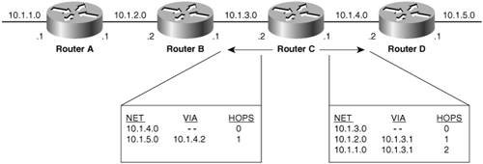

Simple split horizon works by suppressing information. Split horizon with poisoned reverse is a modification that provides more positive information.
The rule for split horizon with poisoned reverse is, when sending updates out a particular interface, designate any networks that were learned from updates received on that interface as unreachable.
In the scenario of Figure4-4 Router C would in fact advertise 10.1.4.0 and 10.1.5.0 to Router D, but the network would be marked as unreachable. Figure4-5 shows what the route tables from C to B and D would look like. Notice that a route is marked as unreachable by setting the metric to infinity; in other words, the network is an infinite distance away. Coverage of a routing protocol's concept of infinity continues in the next section.

Figure 4-5. Split horizon with poisoned reverse advertises reverse routes but with an unreachable (infinite) metric.
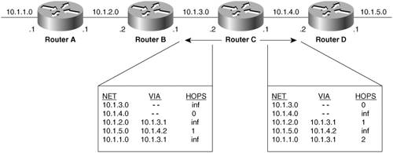

Split horizon with poisoned reverse is considered safer and stronger than simple split horizona sort of "bad news is better than no news at all" approach. For example, suppose that Router B in Figure 4-5 receives corrupted information, causing it to proceed as if subnet 10.1.1.0 is reachable via Router C. Simple split horizon would do nothing to correct this misperception, whereas a poisoned reverse update from Router C would immediately stop the potential loop. For this reason, most modern distance vector implementations use split horizon with poisoned reverse. The trade-off is that routing update packets are larger, which might exacerbate any congestion problems on a link.

Counting to Infinity
Split horizon will break loops between neighbors, but it will not stop loops in a network such as the one in Figure 4-6. Again, 10.1.5.0 has failed. Router D sends the appropriate updates to its neighbors, Router C (the dashed arrows), and Router B (the solid arrows). Router B marks the route via D as unreachable, but Router A is advertising a next-best path to 10.1.5.0, which is three hops away. B posts that route in its route table.

Figure 4-6. Split horizon will not prevent routing loops here.
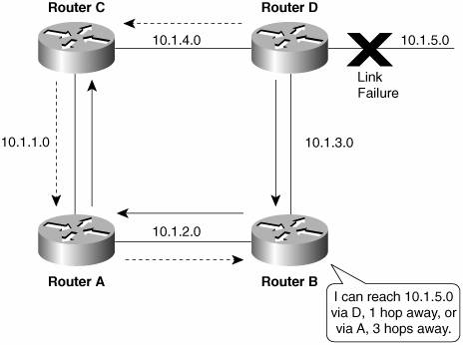

B now informs D that it has an alternative route to 10.1.5.0. D posts this information and updates C, saying that it has a four-hop route to the network. C tells A that 10.1.5.0 is five hops away. A tells B that the network is now six hops away.
"Ah," Router B thinks, "Router A's path to 10.1.5.0 has increased in length. Nonetheless, it's the only route I've got, so I'll use it!"
B changes the hop count to seven, updates D, and around it goes again. This situation is the counting-to-infinity problem because the hop count to 10.1.5.0 will continue to increase to infinity. All routers are implementing split horizon, but it doesn't help.
The way to alleviate the effects of counting to infinity is to define infinity. Most distance vector protocols define infinity to be 16 hops. As the updates continue to loop among the routers in Figure 4-6 the hop count to 10.1.5.0 in all routers will eventually increment to 16. At that time, the network will be considered unreachable.
This method is also how routers advertise a network as unreachable. Whether it is a poisoned reverse route, a network that has failed, or a network beyond the maximum network diameter of 15 hops, a router will recognize any 16-hop route as unreachable.
Setting a maximum hop count of 15 helps solve the counting-to-infinity problem, but convergence will still be very slow. Given an update period of 30 seconds, a network could take up to 7.5 minutes to reconverge and is susceptible to routing errors during this time. Triggered updates can be used to reduce this convergence time.

Triggered Updates
Triggered updates, also known as flash updates, are very simple: If a metric changes for better or for worse, a router will immediately send out an update without waiting for its update timer to expire. Reconvergence will occur far more quickly than if every router had to wait for regularly scheduled updates, and the problem of counting to infinity is greatly reduced, although not completely eliminated. Regular updates might still occur along with triggered updates. Thus a router might receive bad information about a route from a not-yet-reconverged router after having received correct information from a triggered update. Such a situation shows that confusion and routing errors might still occur while a network is reconverging, but triggered updates will help to iron things out more quickly.
A further refinement is to include in the update only the networks that actually triggered it, rather than the entire route table. This technique reduces the processing time and the impact on network bandwidth.

Holddown Timers
Triggered updates add responsiveness to a reconverging network. Holddown timers introduce a certain amount of skepticism to reduce the acceptance of bad routing information.
If the distance to a destination increases (for example, the hop count increases from two to four), the router sets a holddown timer for that route. Until the timer expires, the router will not accept any new updates for the route.
Obviously, a trade-off is involved here. The likelihood of bad routing information getting into a table is reduced but at the expense of the reconvergence time. Like other timers, holddown timers must be set with care. If the holddown period is too short, it will be ineffective, and if it is too long, normal routing will be adversely affected.

Asynchronous Updates
Figure 4-7 shows a group of routers connected to an Ethernet backbone. The routers should not broadcast their updates at the same time; if they do, the update packets will collide. Yet this situation is exactly what can happen when several routers share a broadcast network. System delays related to the processing of updates in the routers tend to cause the update timers to become synchronized. As a few routers become synchronized, collisions will begin to occur, further contributing to system delays, and eventually all routers sharing the broadcast network might become synchronized.

Figure 4-7. If update timers become synchronized, collisions might occur.
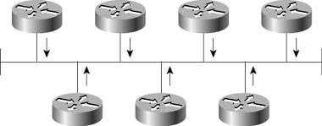

Asynchronous updates might be maintained by one of two methods:
- Each router's update timer is independent of the routing process and is, therefore, not affected by processing loads on the router.
- A small random time, or timing jitter, is added to each update period as an offset.
If routers implement the method of rigid, system-independent timers, all routers sharing a broadcast network must be brought online in a random fashion. Rebooting the entire group of routers simultaneouslysuch as might happen during a widespread power outage, for examplecould result in all the timers attempting to update at the same time.
Adding randomness to the update period is effective if the variable is large enough in proportion to the number of routers sharing the broadcast network. Sally Floyd and Van Jacobson^{[8]} have calculated that a too-small randomization will be overcome by a large enough network of routers, and that to be effective the update timer should range up to 50 percent of the median update period.
^{[8]} S. Floyd and V. Jacobson. "The Synchronisation of Periodic Routing Messages." ACM Sigcomm '93 Symposium, September 1993.

